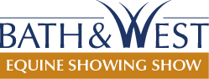
COVID-19
Collection of Name and Contact Details for NHS Track and Trace

Consent Form
In order to support the NHS Test and Trace programme, we are taking contact details (name and telephone number) for all visitors, as well as recording times entering and leaving The Bath & West Equine Showing Show 2021.
In line with guidance issued by the Department for Health and Social Care, we will keep your details safely and in compliance with GDPR legislation for 21 days before securely disposing of or deleting them. We will only share your details with NHS Track and Trace, if we are required to notify them of a possible infection of coronavirus. We will not use your details for any other purposes or pass them on to anyone else.
Thank you for your understanding.
If you agree to providing your information for this reason, please complete the following form:

Name:
Telephone Number:
Signed:
Date: Time:

