Open Shoe Making
Double Dobber 17 ½ 1”1/4x1/2
6 7/8 wide
7 5/8 to outside heel
7 1/4 to inside
3 3/8 between heels
Mustad E8

Open Shoe Making
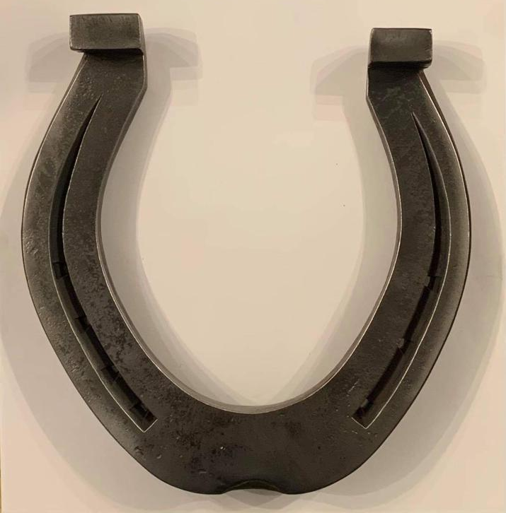

Hind Draft
450mm x 30 x 12
180mm wide
194mm outside heel to toe
90mm between heels
Pony shoeing

Pony Roadster 5/8 square
4 1/4 wide
5 1/8 outside heel
4 11/16 inside heel
1 7/8 between heels
Mustad concave 3

3rd and 4th year apprentice shoemaking
Diamond toe 1 x ½
5 5/8 wide
6 1/2 outside heel
6 1/4 inside
2 5/8 between heels
Toe thickness 1/2
Heels 5/16
Mustad ESL 6
No cutting the toe

3rd and 4th year apprentice shoemaking
French Hind Pony Shoe
240 x 25 x 8
112mm wide
123mm long. Centre of heel to toe
48mm between heels
58mm width of toe
Mustad E3

1st and 2nd year apprentice shoemaking

Plain stamped lateral support
340mm x 25mm x 12mm
133mm wide
147mm outside heel
33mm width of outside heel
Hammer finished
Mustad E6
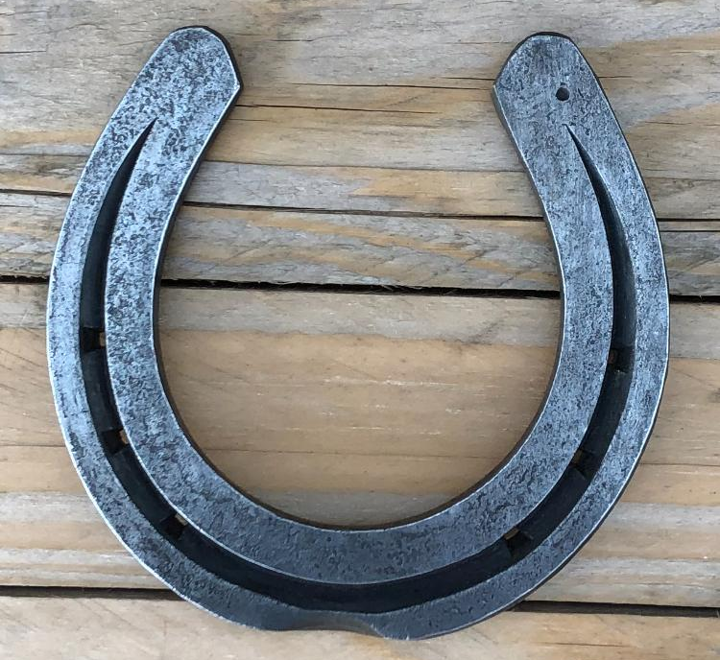
1st and 2nd year apprentice shoemaking
13” 1” 3/8
Hammer finished
5 7/8 wide
5 3/4 long through centre
2 3/8 between heels
Mustad ESL 5

