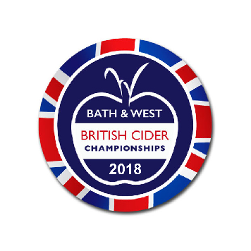

Entries open for Britain’s biggest cider competition
The British Cider Championships at the Royal Bath and West Show - the biggest cider competition certainly in Britain, probably in Europe - is open for entries.
The competition, which is the centrepiece of the giant Orchards and Cider marquee at the show, is geared very much to the quality end of the cider market, whether that be traditional farmhouse cider or the new and exciting craft and artisanal products that are taking the industry forward. As such, it is very much in line with trends in the marketplace, as consumer interest in genuine ciders and perries, made from the fresh juice of British apples and pears with as little as possible added or taken away, has never been higher.
Organisers are expecting an entry of well over 500 ciders and perries, from all corners of Britain, as cider-makers large and small go in search of the Holy Grail of the British cider industry, the Fruiterers’ Trophy for the Champion British Cider. There are classes for every type of proper cider, including farmhouse, of course, but also sparkling, organic, single variety and bottle fermented, as well as for perries and apple juice.
“The championship area in the marquee, with its row upon row of bottles and demijohns , of every shade from palest straw through bright gold to deepest russet, is one of the great sights of the cider world”, says Anthony Gibson, Orchards and Cider’s chairman.
“The diversity and the quality of one of this country’s greatest gifts to civilisation is there for all to see. Couple that with all the excitement of the competition, as the judges go through their mysterious rituals of peering, sniffing, swilling and spitting, and you’ve got an event which has to be one of the highlights of summer.”
The Championship has a new sponsor this year, in the shape of Barber’s Cheese (add quote from someone at Barber’s about cider and cheese being the perfect combination etc )
The British Cider Championships also has a new website: britishciderchampionships.com, on which full details of classes, rules and regulations and, of course, entry forms can be found.
Entries close on April 17.

- The Royal Bath & West Show will be held from 30 May – 2 June. Tickets are now on sale from www.bathandwest.com

For further information on the British Cider Championships or media enquiries contact Anthony Gibson on anthony.gbsn@gmail.com

About the Royal Bath & West of England Society
The Society was founded in 1777 in Bath by a group of philanthropists led by Edmund Rack. We are a registered charity organisation (Registered Charity Number 1039397). The Society was formed with the aims of encouraging agriculture, arts, manufacture and commerce.
Our charitable activities provide:
- Agriculture, veterinary, educational and art scholarships
- Technical events and Seminars
- Practical farming advice and conferences
- Countryside Education
- Diversification advice for farmers
- Education for children
- A market place for countryside products
As the Society celebrates 241 years of existence it continues to deliver a wonderful mix of established traditional exhibits through to the latest energy technology and contemporary entertainment.
The entertainment and features around the 242-acre site ensure enjoyment for every member of the family and include attractions that are spectacular to watch, educational, inspirational, “hands on” or just plain fun.
For further information or media enquiries contact Jonathan Hall on 01749 822 210 or e-mail jonathan.hall@bathandwest.co.uk

