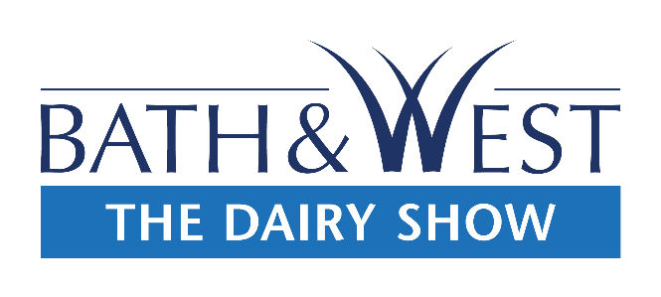

The Dairy Show Stand/Marquee Contractor – 5th October 2022
Please state below any contractors you have hired that will be accessing the site prior to the Show:
Name: ______________________________________________________
Company Name: _____________________________________________________________
Stand Number: ____________________
Address: _____________________________________________________________________________
_____________________________________________________________________________________
Postcode: ____________________________________________
Email Address: ________________________________________________________________________
Contact Number: ____________________________________________________
Emergency Contact Number: ______________________________________________
Set Up Time (estimate): _______________________________________
Date: ________________________________________________
Social Media
We are very keen to promote our Exhibitors on our Social Media platforms, so feel free to send us any content you think might be of interest so we can tag and share! You can connect with us on the following:
@bathandwestshows
#TheDairyShow
INSURANCE
It is imperative that all Trade Stand owners have their own insurance. Please note that it is recommended that all stands have a minimum public liability insurance cover of £2.5 million
A COPY OF YOUR PUBLIC LIABILITY INSURANCE CERTIFICATE MUST BE RETURNED WITH THIS FORM.

